NAME:ANANYA
INTERN ID- TLLIN26006

API Crawler Project – Week 1 Progress Report

Day 1 – Introduction to APIs and HTTP Methods
On Day 1, I learned the fundamentals of APIs and how applications communicate with servers using HTTP requests. I studied the concept of REST APIs and understood how data is exchanged in JSON format.

Topics Covered:
- What is an API
- REST API basics
- HTTP methods – GET, POST, PUT, DELETE
- HTTP status codes
- JSON responses
- Headers in API requests
- Sending API requests using Python requests library

Explanation:
I practiced sending GET and POST requests using Python. I learned how APIs return responses in JSON format and how status codes indicate whether a request was successful or failed. I also explored request headers and understood their importance in authentication and communication between client and server.

PRACTICED JSON RESPONSES
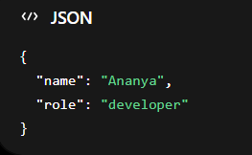
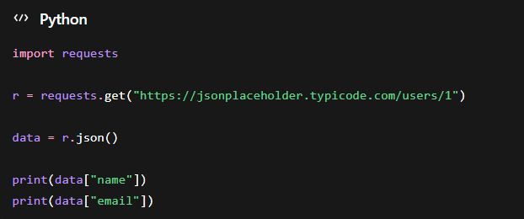

Day 2 – Practical API Handling and JSON Processing
On Day 2, I focused on practical implementation and worked with public APIs to understand real-world API communication. I practiced extracting and processing JSON data using Python.

Topics Covered:
- Working with JSONPlaceholder API
- Fetching user and post data
- Parsing JSON responses
- Accessing nested JSON fields
- Sending custom headers
- Understanding authentication headers
- Basic API testing using Postman

Explanation:
I implemented API requests using Python and extracted useful data from JSON responses. I practiced reading fields such as user names, emails, and post titles from APIs. I also learned how authorization headers work and explored API testing using Postman for debugging and analysis.

Conclusion
By the end of Day 2, I gained a strong understanding of API fundamentals, HTTP methods, JSON handling, and API communication using Python. These concepts will help in developing the API crawler module for the security engine project.

Day 3 – JWT Authentication and API Documentation
On Day 3, I studied authentication mechanisms used in APIs and explored how secured APIs work using JWT tokens and authorization headers. I also learned how API documentation tools like Swagger/OpenAPI help in understanding API endpoints.

Topics Covered:
- JWT (JSON Web Token) basics
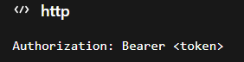
- Structure of JWT – Header, Payload, Signature
- Authorization using Bearer Tokens
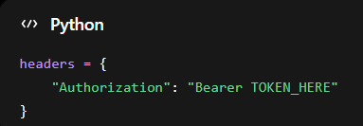
- Authentication headers in APIs
- Introduction to Swagger/OpenAPI
- Understanding API documentation
- Reading API endpoints from Swagger JSON
- Testing authenticated requests in Python

Explanation:
I learned how APIs secure endpoints using JWT authentication and bearer tokens. I understood how tokens are passed inside authorization headers to verify users. I explored the structure of JWT tokens and decoded sample tokens using JWT.io.
I also studied Swagger/OpenAPI documentation to understand how APIs expose endpoint information. I practiced reading API routes, request methods, and parameters from Swagger JSON files. Additionally, I tested authenticated API requests using Python and observed how secured APIs respond to authorized and unauthorized requests.

Practical Work Done:
- Decoded JWT tokens using JWT.io
- Explored Swagger Petstore API documentation
- Read endpoint details from Swagger JSON
- Sent API requests with custom authorization headers
- Practiced authenticated API calls using Python requests library

Outcome
By the end of Day 3, I understood how API authentication works using JWT tokens and how API documentation helps in endpoint discovery, which is essential for building the API crawler system.

Testing Authenticated Requests
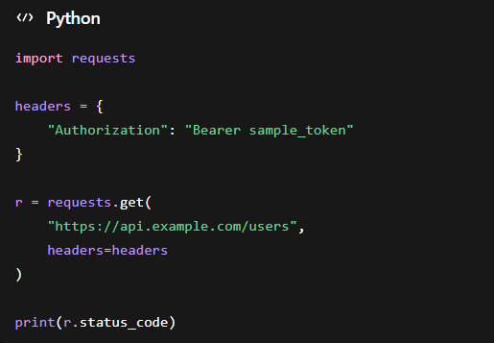

Day 4 – Python Requests and API Automation
On Day 4, I focused on automating API interactions using Python. I practiced sending different types of HTTP requests and handling responses programmatically for API testing and crawling purposes.

Topics Covered
- Python requests library
- Sending GET and POST requests
Sending get messages
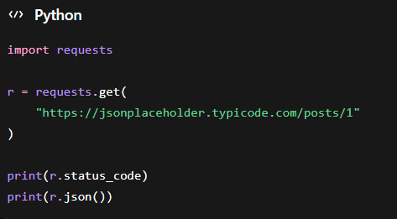
Sending post messages
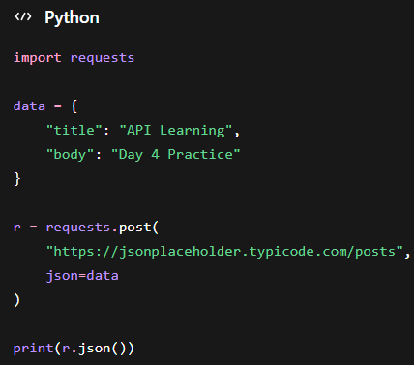
- Sending PUT and DELETE requests
- Handling API responses
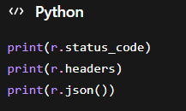
- Working with request headers
- Sending JSON data in requests
- Error handling in API requests
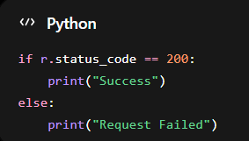
- Basic API automation using Python

Explanation
I learned how to automate API communication using Python’s requests library. I practiced sending GET requests to fetch data and POST requests to submit data to APIs. I also explored PUT and DELETE methods for updating and deleting resources.
Additionally, I worked with request headers and JSON payloads to simulate real-world API communication. I implemented basic error handling techniques to manage failed requests and server errors during API interaction.

Practical Work Done
- Sent GET requests to public APIs
- Submitted data using POST requests
- Updated API resources using PUT requests
- Deleted resources using DELETE requests
- Handled JSON responses in Python
- Tested APIs using custom headers
- Implemented basic error handling for failed requests

Outcome
By the end of Day 4, I gained practical experience in automating API requests using Python. This helped me understand how API crawlers communicate with servers and process responses automatically.

Day 5 – API Documentation Parsing and Endpoint Extraction

Introduction
On Day 5, I focused on understanding how API crawlers automatically discover API endpoints using API documentation files such as Swagger/OpenAPI. I learned how APIs store endpoint information and how Python can be used to extract routes and request methods programmatically.

Topics Covered
- Swagger/OpenAPI documentation
- API documentation structure
- Endpoint extraction
- Parsing Swagger JSON files
- HTTP method discovery
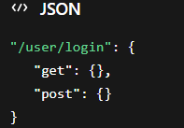
- JSON parsing in Python
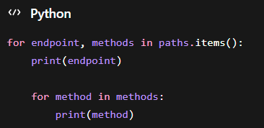
- Automated route discovery
- Storing extracted endpoints

Explanation
I studied how modern APIs provide documentation through Swagger/OpenAPI JSON files. These files contain detailed information about API routes, request methods, parameters, and responses. I learned that API crawlers use these documentation files to automatically identify available endpoints.
I practiced reading the paths section from Swagger JSON files because it contains all API routes. I also learned how different HTTP methods such as GET, POST, PUT, and DELETE are attached to endpoints.
Using Python, I parsed JSON data and extracted endpoint information automatically. This process is important because API crawlers need to identify all accessible routes before performing testing or security analysis.
Additionally, I explored how extracted endpoints can be stored in JSON files or databases for further processing and analysis.

Practical Work Done
- Explored Swagger/OpenAPI JSON documentation
- Parsed API documentation using Python
- Extracted endpoints automatically
- Identified HTTP methods for APIs
- Practiced JSON parsing
- Stored extracted API routes in files

Outcome
By the end of Day 5, I understood how API documentation is structured and how endpoint extraction works in API crawler systems. I also learned how automated tools discover API routes using Swagger/OpenAPI documentation.

